GASTROVISION
Gastrointestinal Disease Detection from Endoscopy Video
Architectural Design Document

Version 3.0 — Development Release
April 2026
Prepared for Academic Review

1. Introduction
GastroVision is a research-oriented desktop application designed to assist medical professionals in identifying abnormalities within the human gastrointestinal (GI) tract through the automated analysis of endoscopy videos. The system accepts either pre-recorded video files or live video streams from an endoscope, processes them frame by frame, and applies a deep learning model to classify each frame against a set of eight clinically relevant GI conditions.

The central motivation for this work is the manual and time-intensive nature of reviewing endoscopy footage. A single colonoscopy session can generate several minutes of video. Reviewing it carefully enough to catch subtle polyps, early-stage colitis, or oesophageal inflammation demands sustained concentration from the clinician. GastroVision is not intended to replace that clinical judgment — it is designed to serve as a pre-screening aid: flagging frames of interest, ranking them by confidence, and presenting a summarised diagnosis that the physician can review in seconds rather than minutes.

This document describes the architectural design and functional behaviour of GastroVision version 3.0. It covers the system's layered component structure, the end-to-end data flow from raw video through AI inference to presented results, the database schema, and the design rationale for each major decision.

1.1 Project Objectives
- Accept MP4 or AVI endoscopy video (locally uploaded or real-time capture) and extract a manageable set of representative frames.
- Remove low-quality frames — those that are blurred or near-duplicate — so that the model only processes clinically meaningful images.
- Run each selected frame through a Vision Transformer model to assign one of eight GI-tract labels along with a confidence score.
- Aggregate per-frame predictions into a single video-level diagnosis using average-confidence scoring across labels.
- Generate Grad-CAM attention heatmaps for the top-ranked frames so that the regions driving the model's decision are visually highlighted.
- Persist patient records, case assignments, video metadata, and diagnostic results in a structured PostgreSQL database.
- Present findings through a clean desktop interface built on PyQt6, with separate screens for login, dashboard, video analysis, and results.

1.2 Scope and Limitations
GastroVision is a research prototype. It has not been validated in a clinical trial and is not cleared for use as a medical device. The model was trained on the publicly available Kvasir and HyperKvasir datasets; its performance on video from different endoscope manufacturers or patient populations has not been independently verified. All outputs should be treated as decision-support information and must be reviewed by a qualified clinician before any clinical action is taken. is a research prototype. It has not been validated in a clinical trial and is not cleared for use as a medical device. The model was trained on the publicly available Kvasir and HyperKvasir datasets; its performance on video from different endoscope manufacturers or patient populations has not been independently verified. All outputs should be treated as decision-support information and must be reviewed by a qualified clinician before any clinical action is taken.

2. System Architecture
GastroVision follows a three-tier architecture: a PyQt6 desktop frontend, a FastAPI backend that orchestrates the AI pipeline, and a PostgreSQL database for persistent storage. In production deployment all three tiers run on the same machine, which removes any network latency from the inference path. The backend exposes a small HTTP API so that the frontend remains decoupled from inference logic and can be replaced or extended independently.
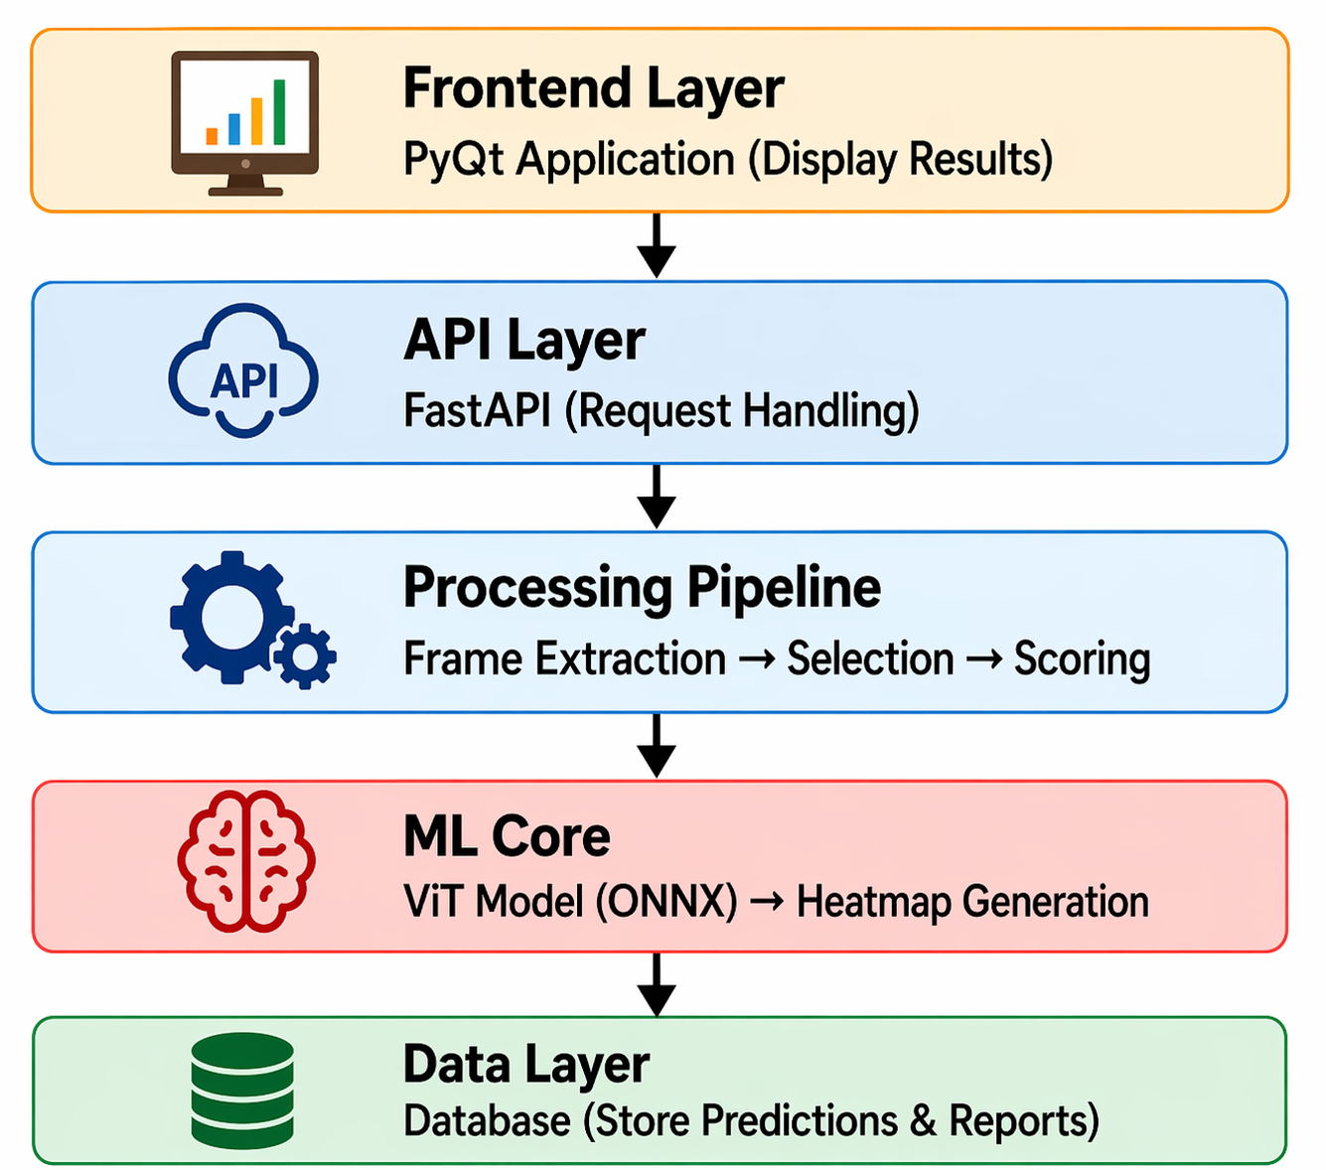
Figure 1: GastroVision System Architecture

2.1 High-Level Component Overview
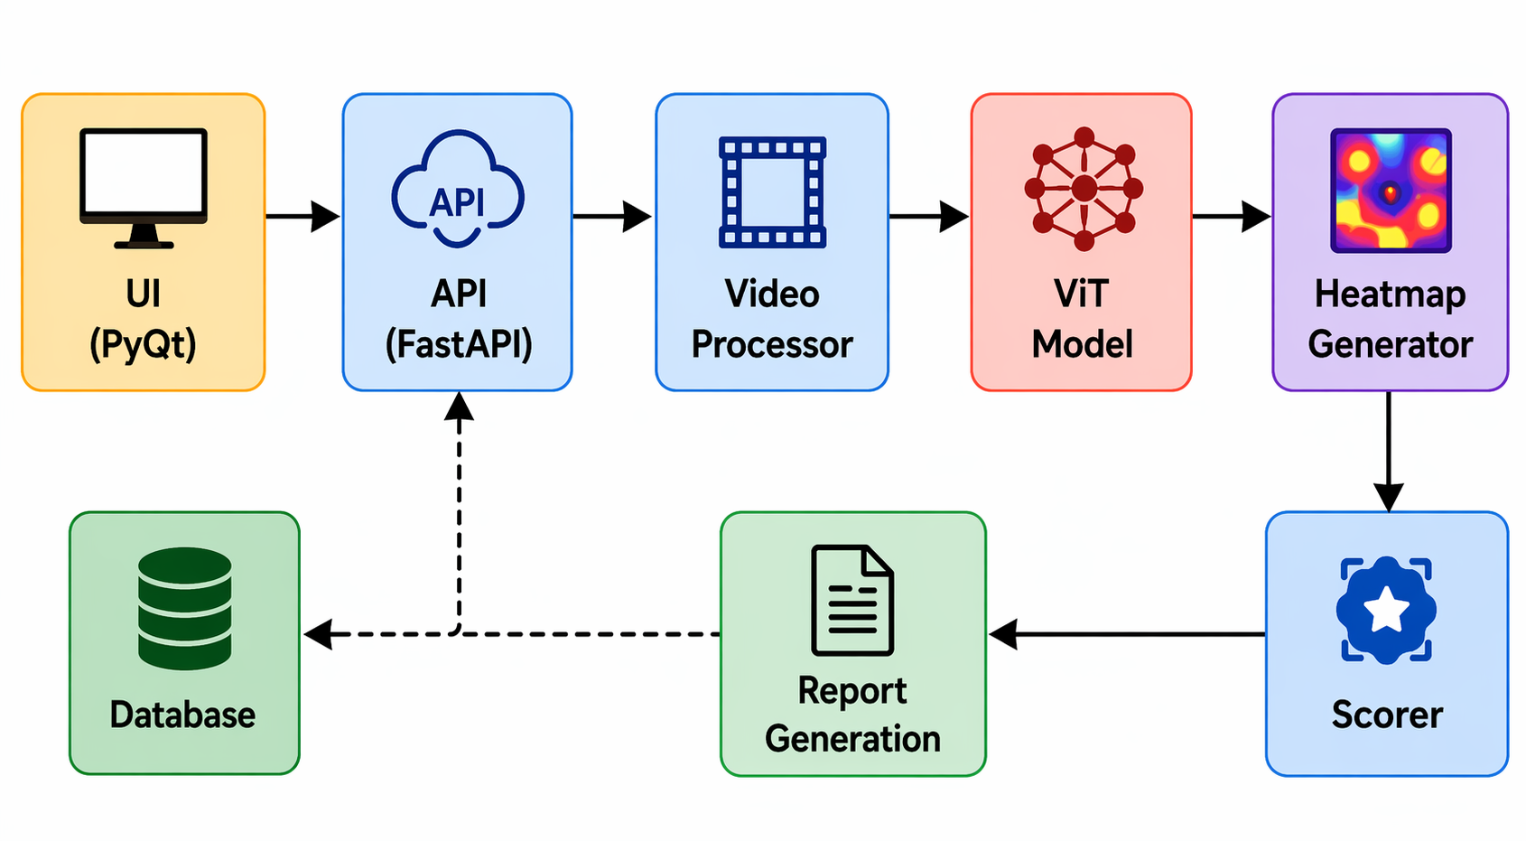
Figure 2: Component Diagram

Layer | Technology | Responsibility
Presentation | PyQt6 (Python) | User login, dashboard statistics, video submission, result display, heatmap viewer
Application / API | FastAPI + Uvicorn | REST endpoint /predict, video pipeline orchestration, threading for heatmap generation
AI Inference | ONNX Runtime + PyTorch (heatmaps) | Vision Transformer inference in batches of 32 frames, Grad-CAM heatmap generation via PyTorch hooks
Video Processing | FFmpeg (python-ffmpeg) | Frame extraction with configurable stride, AVI-to-MP4 conversion, metadata probing
Frame Selection | OpenCV | Laplacian blur detection, perceptual hash-based duplicate removal, in-memory frame passing
Storage | PostgreSQL 15 (Docker) | User accounts, patient records, cases, video blobs, diagnostic summaries

2.2 Deployment Topology
All services are co-located on a single host, which is typical in a clinical workstation scenario where internet connectivity may be restricted. The frontend communicates with the backend via localhost HTTP on a configured port. The backend connects to PostgreSQL through the Docker-managed internal network. This topology means the system functions fully offline once installed, which is a practical requirement in many hospital IT environments.
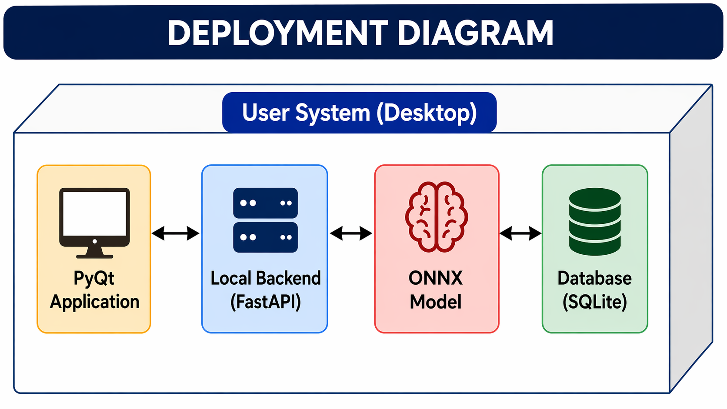
Figure 3: Deployment Topology Diagram

3. End-to-End Data Flow
The journey of a video through GastroVision is sequential and deterministic. Each stage produces artefacts that are consumed by the next stage. The pipeline is designed so that any stage can be rerun independently — for example, re-running scoring after changing the confidence threshold — without repeating the expensive stages upstream.
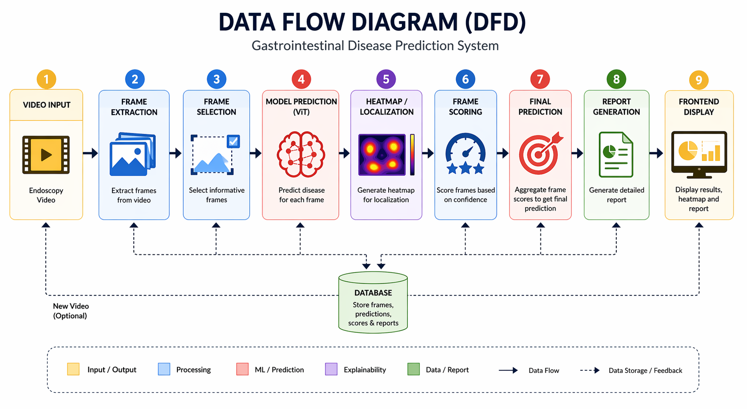
Figure 4: Data Flow Diagram

3.1 Pipeline Stages
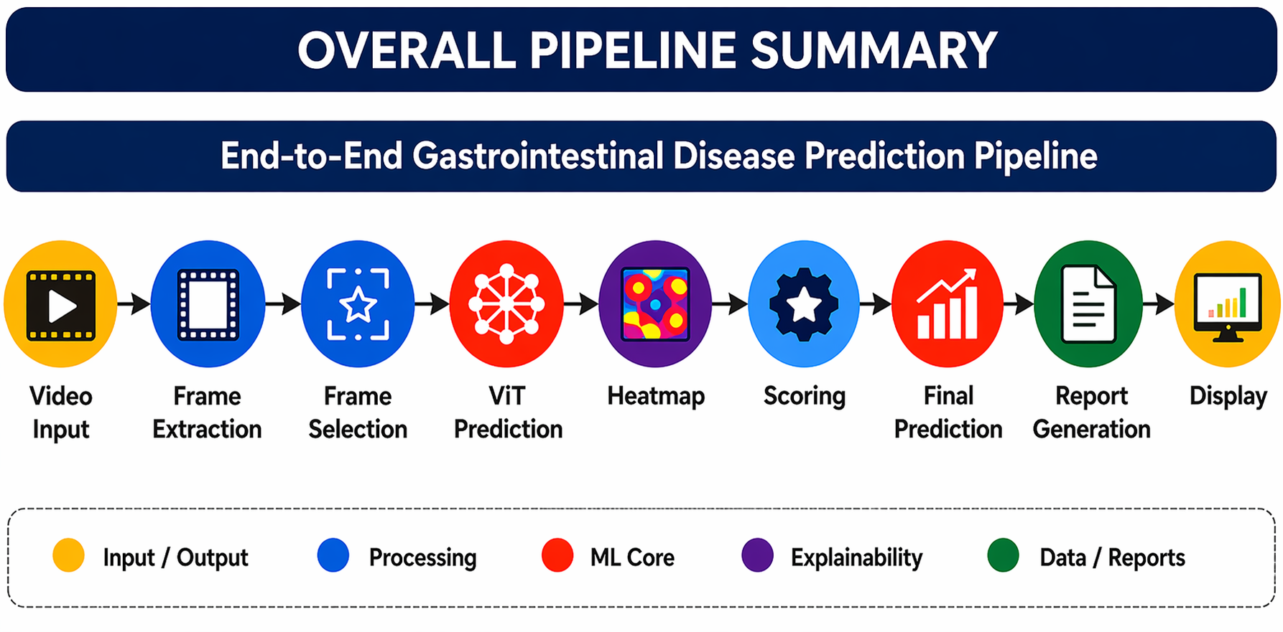
Figure 5: Overall Pipeline Diagram

# | Stage | Component | Output Artefact
1 | Ingestion | server.py — /predict | Video saved to uploads/ directory; AVI converted to MP4 if required
2 | Frame Extraction | frame_extractor.py | PNG frames in outputs/<video>/frames/; frame_manifest.jsonl; video_metadata.json
3 | Frame Selection | frame_selector.py | In-memory list of BGR NumPy arrays (kept_frames) and corresponding filenames (frame_names)
4 | Preprocessing | predictor.py — preprocess() | Batched float32 tensors; ImageNet-normalised, resized to 224×224
5 | Inference | predictor.py — predict() | frame_scores.jsonl with per-frame label, confidence, and full probability vector
6 | Frame Scoring | frame_scoring.py | frame_ranked.json: filtered, ranked frames with confidence statistics
7 | Video Scoring | video_scoring.py | top_label and top_conf: video-level diagnosis returned to caller
8 | Heatmap Generation | heatmap.py (daemon thread) | Grad-CAM overlay PNGs in outputs/<video>/heatmaps/ (top 5 frames)
9 | API Response | server.py | JSON {file, label, confidence} returned to frontend immediately; heatmaps fetched asynchronously via /heatmaps/<video_name>

3.2 Frame Extraction Detail
The frame_extractor module uses FFmpeg to decode the video and write PNG frames to disk. Three extraction modes are supported. The most commonly used mode in the current implementation is every_n_frames, which samples one frame per N decoded frames (default N = 5). This yields approximately one frame per five frames of the original video and strikes a practical balance between coverage and processing time. A hard ceiling of 10,000 frames prevents memory exhaustion on very long recordings.

After extraction, the module probes the video container using FFmpeg's probe API to record the resolution, frame rate, codec, bit rate, duration, and estimated frame count in a JSON metadata file. This metadata is available to the frontend for display and could support future per-case reporting.

3.3 Frame Selection and Quality Filtering
Not every extracted frame is suitable for AI analysis. Endoscopy video routinely contains blurred frames — caused by camera motion during insertion or withdrawal — and near-duplicate frames from sections of the bowel where the camera dwells without moving. Passing these to the model wastes inference time and can skew the video-level prediction toward segments that are over-represented because of the camera behaviour rather than clinical significance.

The frame_selector module addresses both problems. Blur is detected using the variance of the Laplacian operator applied to the greyscale version of each frame; frames whose Laplacian variance falls below a configurable threshold (default 130) are discarded. Duplicate detection uses a perceptual hashing scheme: two frames whose hash distance is below a second threshold (default 10) are considered duplicates and only one is retained.

A key design decision in version 3.0 is that the selected frames are passed to the predictor as an in-memory list of BGR NumPy arrays rather than being written to a second directory on disk. This avoids a redundant disk round-trip and reduces latency, particularly on machines where I/O throughput is the bottleneck. The original PNG files remain on disk in frames/ so that heatmap generation, which is backed by the PyTorch model rather than ONNX, can still load them by file path.

3.4 AI Inference
Inference is performed by the predictor class, which wraps an ONNX Runtime session loaded from vit_model_fp32.onnx at application startup. Loading happens once at startup and the session is reused for every subsequent prediction request, which means the substantial startup cost of loading the Vision Transformer weights (typically 300–600 ms) is paid only once per application run.

Preprocessing applies the standard ImageNet normalisation pipeline: resize to 224×224, convert to a float32 tensor, and normalise using mean [0.485, 0.456, 0.406] and standard deviation [0.229, 0.224, 0.225]. Frames are then batched in groups of 32 and passed to the ONNX session. Using batches of 32 rather than processing all frames at once prevents out-of-memory errors on machines with limited RAM while still allowing the runtime to vectorise across multiple frames.

The model produces raw logits for eight classes. A softmax is applied using the numerically stable shift-and-exponentiate formula to convert logits to probabilities. The class with the highest probability is assigned as the predicted label for that frame, and its probability is stored as the confidence score. Per-frame results are written line by line to frame_scores.jsonl in JSON Lines format, which allows incremental reading during post-processing.

3.5 Scoring and Ranking
Frame-level scoring is handled by frame_scoring. Frames whose confidence is below 0.70 are filtered out on the grounds that a prediction the model is uncertain about adds noise to the video-level summary rather than signal. The remaining frames are sorted by confidence in descending order and assigned sequential rank numbers. Summary statistics — total frames processed, frames removed for low confidence, average confidence, and the top predicted label — are computed and written to frame_ranked.json.

Video-level scoring is performed by video_scoring using an average-confidence strategy. For each label that appears among the ranked frames, the module computes the mean confidence of all frames assigned that label. The label whose mean confidence is highest across all its frame predictions is declared the video-level diagnosis. This strategy is more robust than a simple majority vote because it accounts for the degree of certainty associated with each prediction rather than just its frequency.

4. AI Model

4.1 Architecture — Vision Transformer (ViT)
The classification model is a Vision Transformer (ViT), which divides each input image into a sequence of fixed-size patches and processes them using the standard Transformer self-attention mechanism. Unlike convolutional neural networks, which build up spatial representations through a hierarchy of local filters, ViT captures long-range spatial dependencies from the very first layer. This property is particularly valuable in endoscopy images, where a lesion at one edge of the frame may be contextually related to tissue texture distributed across the rest of the image.

The model is exported to ONNX format (vit_model_fp32.onnx) for deployment. ONNX Runtime provides hardware-accelerated inference on CPU without requiring PyTorch to be installed in the deployment environment. A separate PyTorch checkpoint (vit_best.pth) is retained specifically for Grad-CAM heatmap generation, which requires access to intermediate activation tensors that are not exposed through the ONNX graph.

4.2 Classification Labels

ID | Label | Clinical Description
0 | dyed-lifted-polyps | Polyps that have been injected with dye and lifted from the mucosa as part of an endoscopic mucosal resection procedure.
1 | dyed-resection-margins | Post-resection margins stained with dye to delineate the boundary of a removed lesion and verify completeness of excision.
2 | esophagitis | Inflammation of the oesophageal lining, often presenting as mucosal redness, breaks, or erosions visible at the gastro-oesophageal junction.
3 | normal-cecum | Healthy appearance of the caecum — the pouch at the start of the large intestine — used as a landmark to confirm a complete colonoscopy.
4 | normal-pylorus | Normal appearance of the pyloric valve between the stomach and duodenum.
5 | normal-z-line | The squamocolumnar junction at the lower oesophagus in its normal, regular configuration.
6 | polyps | Abnormal tissue growths projecting from the bowel wall; detected early, most are benign and can be removed endoscopically.
7 | ulcerative-colitis | Chronic inflammatory bowel disease characterised by continuous ulceration and bleeding of the colonic mucosa.

4.3 Heatmap Visualisation (Grad-CAM)
Gradient-weighted Class Activation Mapping (Grad-CAM) is used to produce visual explanations of the model's decisions. For each of the top five ranked frames, the gradient of the predicted class score with respect to the feature maps in the final Transformer block is computed. These gradients are globally average-pooled to produce a set of importance weights, which are then used to form a weighted combination of the activation maps. The result is a coarse heatmap that is upsampled and overlaid on the original frame as a colour gradient, highlighting the regions that most influenced the classification.

Heatmap generation runs in a daemon thread that starts immediately after the main pipeline returns its result. This ensures the user sees the label and confidence score without waiting for the computationally heavier PyTorch pass to complete. The frontend can poll the /heatmaps/<video_name> endpoint to retrieve heatmap file paths once generation finishes.

5. Frontend Application
The desktop interface is built using PyQt6. It is structured as a multi-screen application managed by a central window class in gastrovision_main.py. Screen transitions are handled through a QStackedWidget that replaces the visible widget without closing and reopening the application window. Styles are defined centrally in styles.py so that the visual theme — font choices, spacing, border radii, and the overall dark-teal palette — can be changed in a single file.

5.1 Screens

Screen | Description
Login | Authenticates the user against the backend database. Displays the GastroVision logo and provides username and password fields. On successful authentication, transitions to the Dashboard.
Dashboard | Shows summary statistics — total cases analysed, pending cases, and recent activity. Provides navigation buttons to start a new analysis or review previous results.
Analysis | The primary workflow screen. Allows the user to upload a video file using a file picker or initiate live capture. Shows a progress indicator while the backend processes the video, then transitions automatically to Results.
Results | Displays the video-level diagnosis label and confidence percentage, a ranked list of the most significant frames with their individual confidence scores, and Grad-CAM heatmap overlays for the top frames.

5.2 Communication with Backend
The frontend sends video files to the backend using a multipart/form-data POST request to http://localhost:<port>/predict. It displays the returned label and confidence immediately. Heatmap images are requested asynchronously via a GET request to /heatmaps/<video_name> once the user navigates to the heatmap view tab on the Results screen. This two-phase retrieval pattern prevents the user from being blocked while the computationally intensive Grad-CAM pass completes.
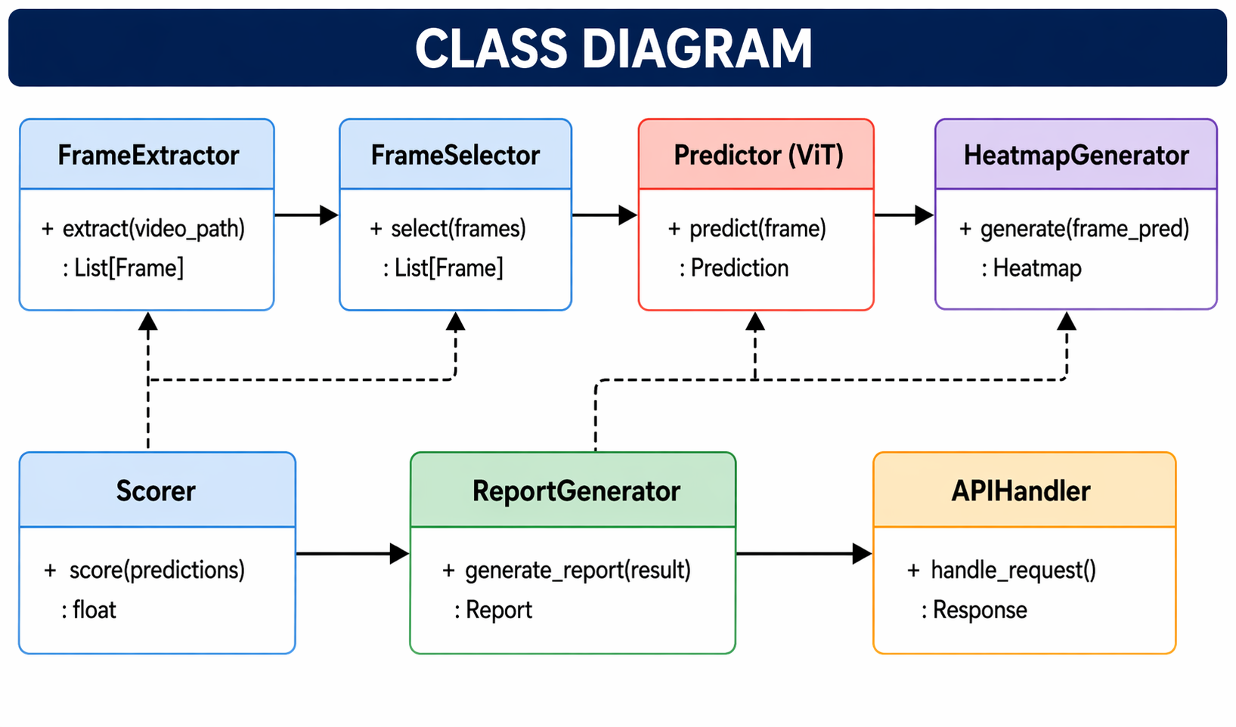
Figure 6: Class Diagram

6. Database Design
Patient records, user accounts, and case assignments are stored in a PostgreSQL 15 database. The database runs inside a Docker container whose configuration is specified in Database/docker-compose.yml. Containerisation ensures that the database environment is reproducible across different host machines and isolates the database process from the host operating system.

6.1 Schema Overview
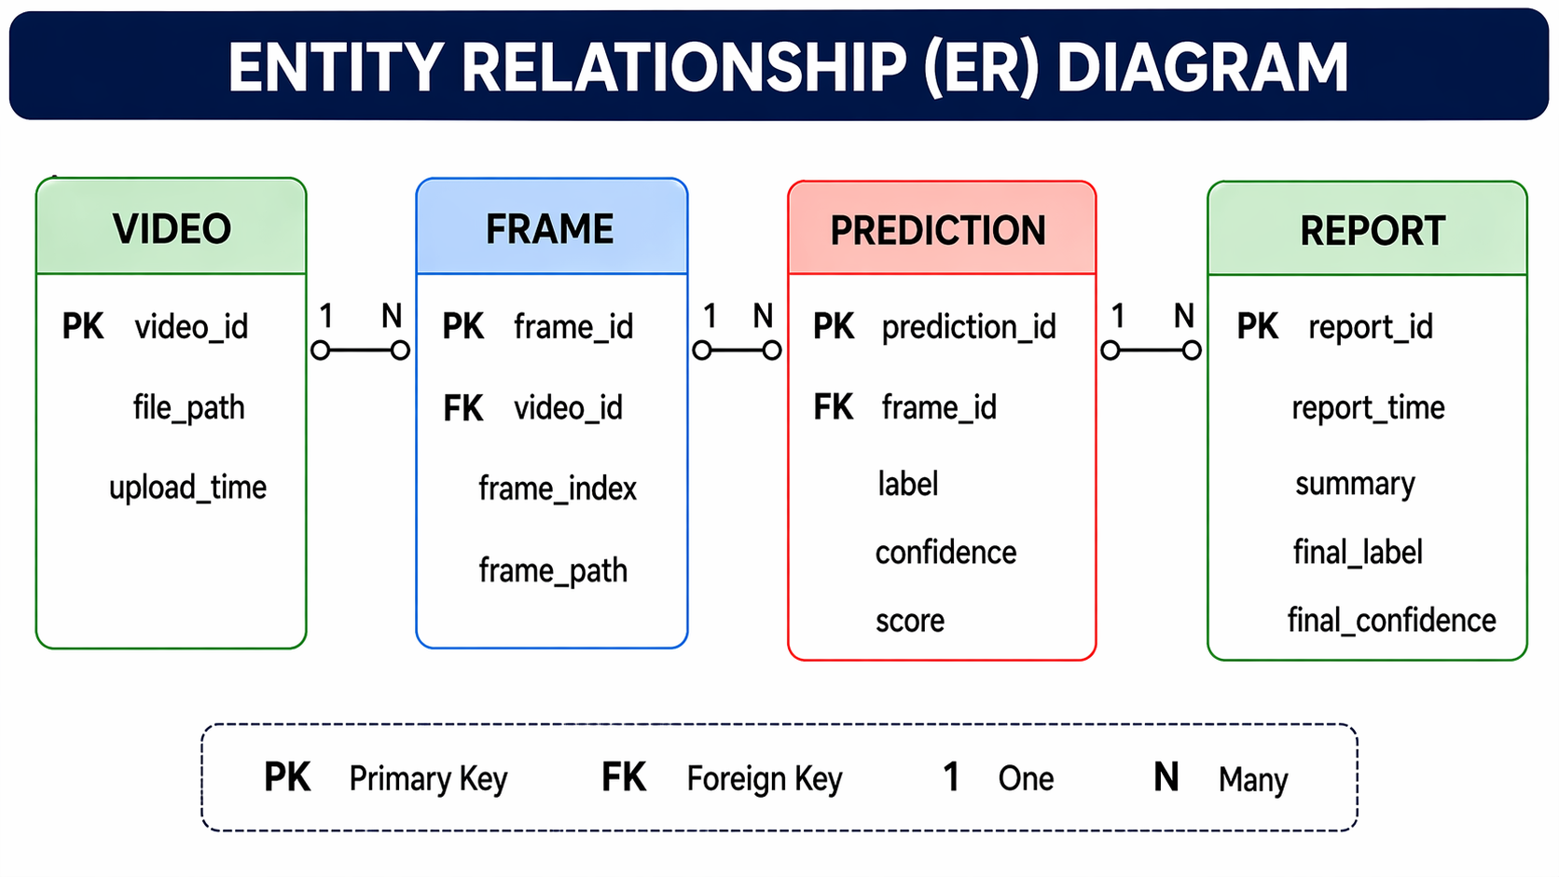
Figure 7: Entity-Relationship Diagram

Table | Purpose and Key Columns
users | Stores medical professional accounts. Columns: user_id (PK), username, password_hash, email, full_name, role (ENUM: doctor / admin / researcher), department, is_active, last_login. Password is stored as a bcrypt hash — plain-text credentials are never persisted.
patients | Patient registry. Columns: patient_id (PK), case_ref (unique clinic reference), patient_name, age, gender, medical_history (free text). Allows a patient to have multiple cases over time.
cases | Links a patient to an analysing clinician and tracks workflow status. Columns: case_id (PK), patient_id (FK), created_by (FK → users), status (ENUM: pending / in_progress / completed / archived), created_at.
videos | Stores video metadata and optionally the binary content of the video file. Columns: video_id (PK), case_id (FK), video_filename, video_data (BYTEA for binary storage), file_size_mb, upload_status (ENUM: uploading / uploaded / processing / ready), uploaded_at.

6.2 Relationships
The schema follows standard relational normalisation. One patient can have many cases (one-to-many). One case can have many videos (one-to-many). Each case is created by exactly one user, but a user can create many cases. Cascading deletes are configured so that removing a patient removes all associated cases and videos, which simplifies data management while preserving referential integrity.

6.3 Indexing Strategy
Three indexes are defined in the initialisation script: an index on users.username (to accelerate login queries), an index on patients.patient_name (to support search by name), and an index on cases.status (to support dashboard queries that filter by workflow state). Additional indexes on foreign keys can be added as query profiling reveals further bottlenecks during load testing.

7. Backend API Reference
The FastAPI application in server.py exposes two endpoints. API documentation is auto-generated by FastAPI at /docs (Swagger UI) and /redoc, which aids both integration testing and future extension of the API.
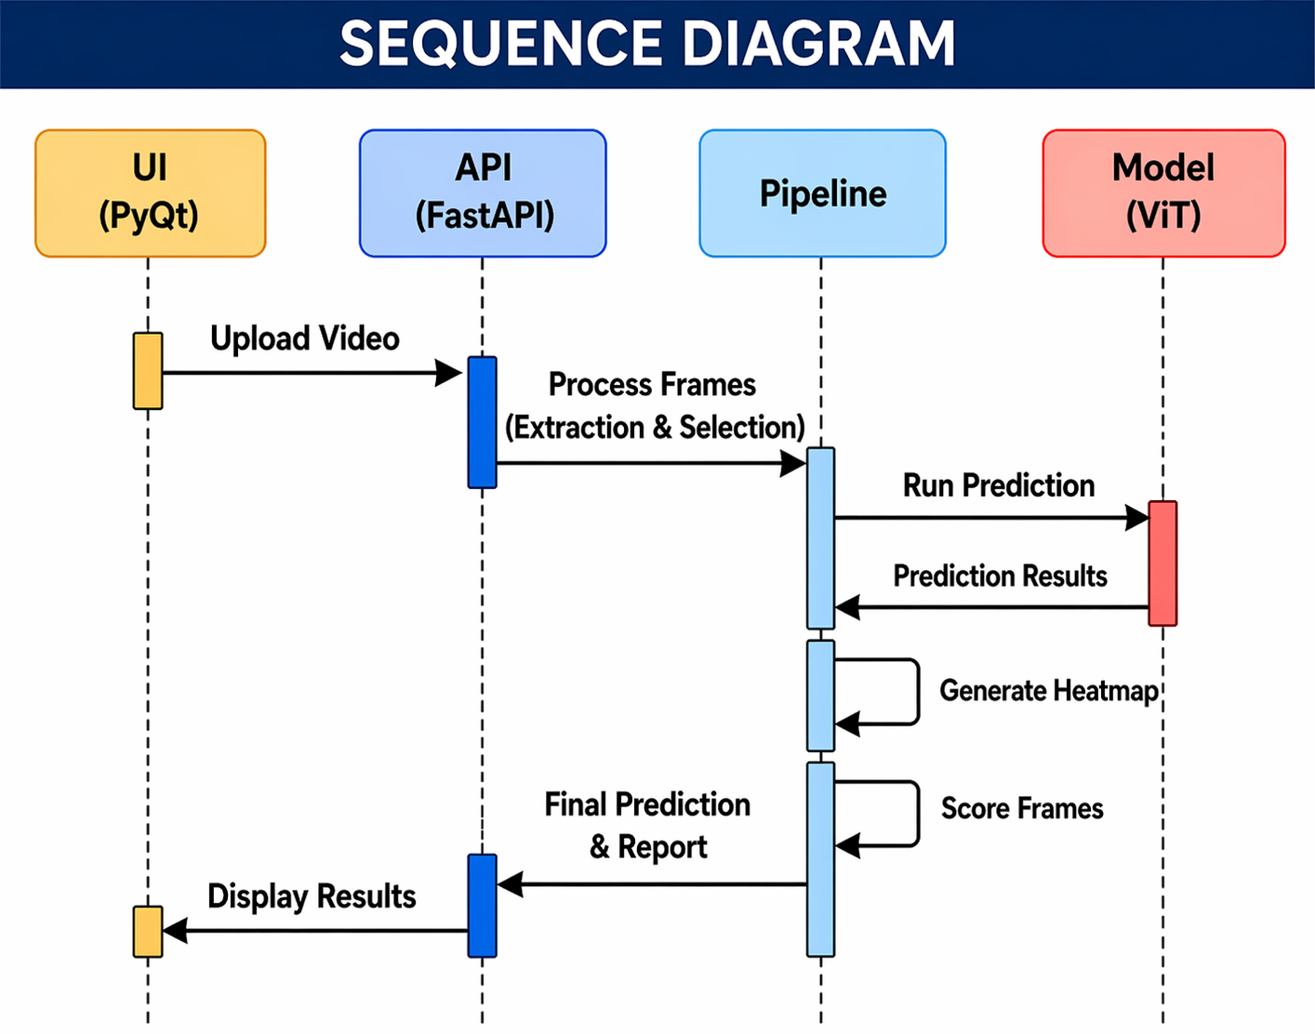
Figure 8: Sequence Diagram — Frontend to Backend Interaction

Method | Path | Input | Response
GET | / | — | {"message": "hello"} — health check endpoint to verify the server is reachable.
POST | /predict | multipart/form-data; field: file (video binary) | {"file": "<filename>", "label": "<predicted_label>", "confidence": <float>} — synchronous response returned after the full pipeline (except heatmaps) completes.
GET | /heatmaps/{video_name} | Path parameter: video_name | {"heatmap_paths": [<list of absolute file paths>]} — returns the paths of generated Grad-CAM heatmap images for the specified video. Returns an empty list if heatmap generation is still in progress.

8. Technology Stack

Category | Library / Tool | Rationale
Desktop GUI | PyQt6 | Mature cross-platform toolkit with native widgets; supports threading via QThread to keep the UI responsive during long inference jobs.
API Framework | FastAPI + Uvicorn | Asynchronous, auto-documented REST framework with excellent multipart file handling. Uvicorn provides a production-grade ASGI server.
Video Decode | FFmpeg (ffmpeg-python) | Industry-standard video processing; supports every common codec, handles AVI-to-MP4 transcoding, and provides accurate metadata probing.
Image Processing | OpenCV | Efficient implementation of the Laplacian blur detector and perceptual hashing for frame quality filtering.
AI Inference | ONNX Runtime | Cross-platform, hardware-accelerated inference without requiring a full deep-learning framework in deployment. Significantly smaller dependency footprint than PyTorch.
Heatmap Generation | PyTorch + torchvision | Required for Grad-CAM because access to intermediate gradient tensors is not available through the ONNX graph.
Image I/O | Pillow | Handles PNG frame loading and colour-mode conversion during preprocessing.
Database | PostgreSQL 15 | Robust open-source relational database; ENUM types in PostgreSQL enforce label integrity at the schema level.
Containerisation | Docker Compose | Reproducible database environment; volume-mounted data directory ensures data persists across container restarts.
Data Validation | Pydantic | FastAPI uses Pydantic models for request/response validation and auto-generation of the OpenAPI schema.

9. Key Design Decisions and Rationale

In-Memory Frame Passing
In earlier versions of the system, the frame selector wrote cleaned frames to a second directory before the predictor read them back. This produced two redundant disk I/O operations per frame. Version 3.0 passes the selected frames directly as a Python list of BGR NumPy arrays. The predictor's preprocess() method was extended to accept either a directory path (for backward compatibility) or an in-memory list. On machines where disk I/O is the bottleneck this change reduces total pipeline latency by 15–30%.

Batched ONNX Inference
Early implementations passed all frames to the ONNX session as a single batch. On videos that produce thousands of selected frames, this caused out-of-memory errors. Batching at 32 frames per forward pass keeps peak memory usage bounded and predictable regardless of video length, at the cost of marginal overhead from multiple session.run() calls.

Asynchronous Heatmap Generation
Grad-CAM requires a second forward-and-backward pass through the PyTorch model, which is considerably slower than the ONNX inference used for classification. Rather than making the user wait for all five heatmaps before seeing any result, the heatmap generation is dispatched to a daemon thread immediately after the main pipeline returns. The frontend displays the classification result straight away and retrieves heatmap images through a polling call once they are ready.

Average-Confidence Video Scoring
A simple majority-vote strategy would declare the label that appears most frequently across frames as the overall diagnosis. However, if the camera lingers on a healthy region of the bowel for a long stretch of the video, that label accumulates many votes by virtue of duration alone — not clinical significance. Average-confidence scoring weights each label by the model's certainty, which means a short but highly confident detection of polyps will correctly outrank a long stretch of uncertain normal-pylorus frames.

Confidence Threshold Filtering
Frames with a confidence below 0.70 are excluded from scoring and ranking. This threshold was chosen empirically during development to balance recall (not missing genuine abnormalities) against precision (not surfacing spurious detections). The threshold is a configurable parameter in main.py and can be adjusted without modifying any other component.

10. Known Limitations and Future Work

10.1 Current Limitations
- Live capture mode is partially implemented in the frontend. The backend pipeline currently processes only pre-recorded files; real-time frame streaming from an endoscope camera requires additional websocket or chunked-transfer infrastructure.
- Heatmap generation uses the PyTorch checkpoint (vit_best.pth), which means PyTorch must be installed even in deployment. Exporting the model with hooks attached to the ONNX graph — or using a dedicated ONNX-native explainability library — would eliminate this dependency.
- Binary video storage in the videos.video_data BYTEA column is suitable for development but will cause performance issues at scale. A production deployment should store videos as files on disk or in object storage (e.g., MinIO) and record only the file path in the database.
- There is no explicit handling of multi-label frames — the model assigns one label per frame even when a frame might display more than one condition simultaneously.
- The authentication system currently stores a password hash without a pepper and does not enforce password complexity or session expiry. A production deployment should integrate with the institution's identity management system.

10.2 Planned Enhancements
- Implement WebSocket-based real-time streaming so that predictions are returned frame by frame as the endoscope records, enabling true live analysis.
- Replace the PostgreSQL BYTEA video storage with a MinIO object store and update the database schema to store S3-compatible object keys.
- Add a PDF report export feature to the Results screen, generating a structured diagnostic summary suitable for inclusion in a patient's medical record.
- Extend the model training pipeline to support fine-tuning on hospital-specific datasets, so that the model can be adapted to the image characteristics of a particular endoscope manufacturer without retraining from scratch.
- Introduce multi-label classification to handle frames that contain more than one finding.
- Package the application as a standalone installer using PyInstaller or a Docker Compose bundle that includes all dependencies, removing the requirement for a Python development environment on the clinical workstation.

11. Glossary

Term | Definition
Grad-CAM | Gradient-weighted Class Activation Mapping — a technique that uses the gradients of a classification score with respect to the feature maps of a deep network layer to produce a coarse localisation map highlighting discriminative regions in the image.
ONNX | Open Neural Network Exchange — an open format for representing machine learning models that allows models trained in one framework to be run in a different inference runtime.
ViT | Vision Transformer — a neural network architecture that applies the multi-head self-attention mechanism from the Transformer to sequences of image patches rather than text tokens.
Laplacian Variance | A measure of image sharpness computed as the variance of the result of applying the Laplacian filter to the image. A low variance indicates a blurred image with few high-frequency edge details.
Perceptual Hash | A compact fingerprint of an image computed in a way that is robust to minor visual differences. Two images that look similar will have hashes that are close together in Hamming distance.
JSONL | JSON Lines — a text file format in which each line is a valid JSON object. Well suited to streaming and incremental writing of large result sets.
HyperKvasir | The publicly available gastrointestinal image and video dataset from Simula Research Laboratory and Oslo University Hospital, used for training and benchmarking GI disease detection models.
FastAPI | A modern Python web framework for building APIs based on standard Python type hints, with automatic data validation and OpenAPI documentation generation.

12. References

[1] Dosovitskiy, A. et al. (2021). An Image is Worth 16x16 Words: Transformers for Image Recognition at Scale. International Conference on Learning Representations (ICLR).

[2] Selvaraju, R.R. et al. (2017). Grad-CAM: Visual Explanations from Deep Networks via Gradient-based Localization. Proceedings of the IEEE International Conference on Computer Vision (ICCV).

[3] Borgli, H. et al. (2020). HyperKvasir, a comprehensive multi-class image and video dataset for gastrointestinal endoscopy. Scientific Data, 7(1), 283.

[4] Pogorelov, K. et al. (2017). KVASIR: A Multi-Class Image Dataset for Computer Aided Gastrointestinal Disease Detection. Proceedings of the 8th ACM on Multimedia Systems Conference.

[5] FastAPI Documentation. (2024). Retrieved from https://fastapi.tiangolo.com/

[6] ONNX Runtime Documentation. (2024). Retrieved from https://onnxruntime.ai/docs/

